CSA-0411: OPERATING SYSTEM FOR NETWORKING

EXP 11: 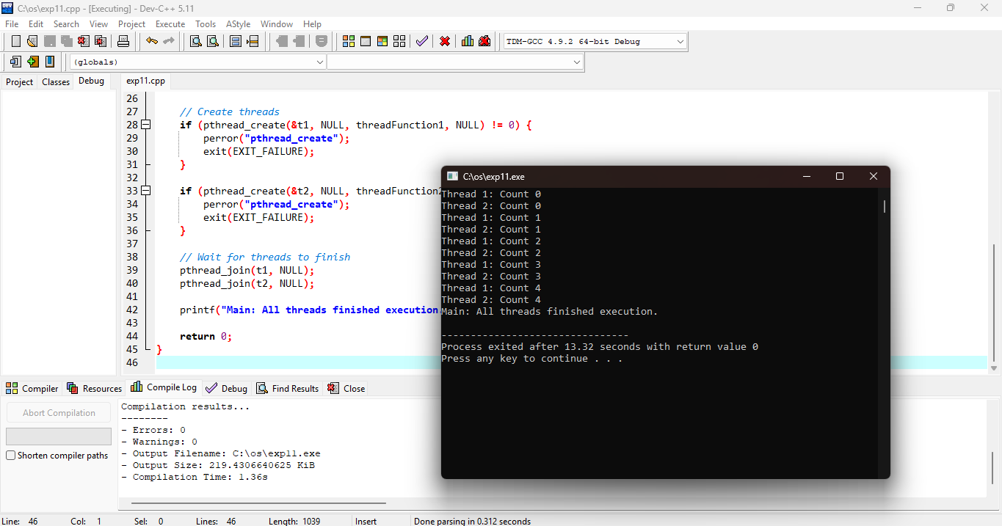

**

**EXP 13:**

**EXP 14:**

**EXP 15:**

